**Step by step**

1. First thing to do is try the sensors. I first work on Ultrasonic sensor and I use New Ping Library and I connect the trigger pin to digital pin 12 and the echo pin to digital pin 11.
2. Next is the Mpu6050 sensor I used MPU6050 light library to make it function I connect it to A4 and A5 in because it uses I2C communication.
3. Next is the Oled screen I used Adafruit_SH110X library and also connect it to A4 and A5 it also uses 12C communication.
4. After successfully displaying the Distance and angle in the Oled Screen I add a laser and it is connected to digital pin 6.
5. Next, I add capacitive touch buttons I connect it to digital pin 7, 8, 9, and 10.
6. After making all the function works, I also add a different unit for the distance.
7. I also add a calibrate feature in angle so I can reset the gyro offsets.
8. After making it work, I will now work on saving the data to the sd card.
9. I used another board to make it work because the Arduino nano board it self cant handle both oled screen and SD card module because of lack of ram.
10. I used my extra NODEMCU esp8266 it is same with the Arduino nano board. it only has one thing to do which is save the data to SD card.
11. The SD card module is connected to CS pin to D8, MOSI to D7, SDK to D5, MISO to D6.
12. The file will be saved in two separates excel file.
13. After making it work, I used Serial communication to make the nodemcu and the Arduino nano communicate to each other.
14. After making the main features work. I now proceed to connecting the SX1308 Voltage Step-up to Lithium-ion 18650 battery and adjusted the gauge to reach 5 volts. Then connect the output to the boards and components.
15. I also add a Voltage sensor to monitor the battery capacity I connect it to A0 pin.
16. Then I soldered some of the components to add durability to the connections.

**DIAGRAM**

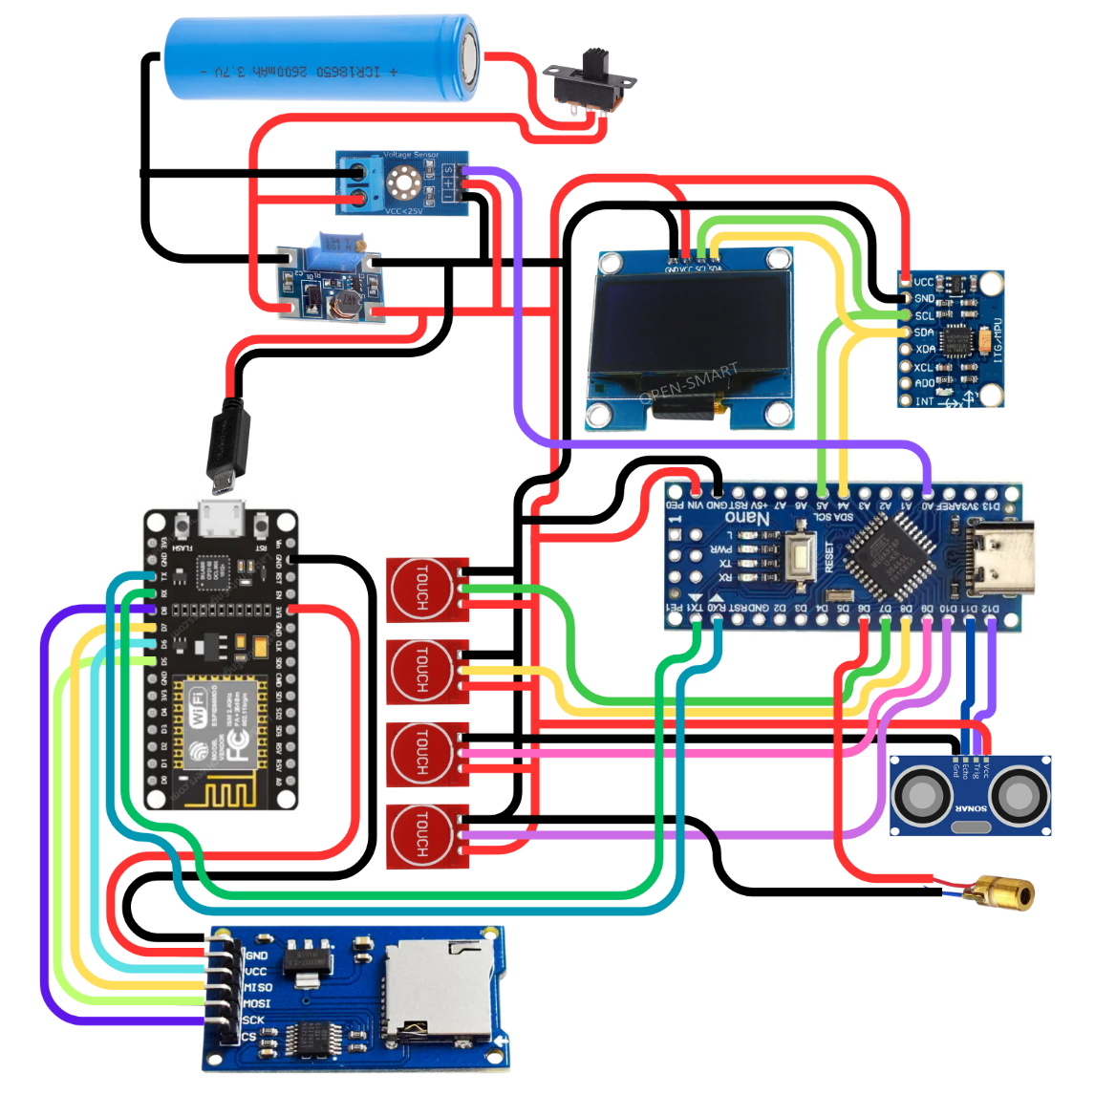

**Explanation**

**Labels**

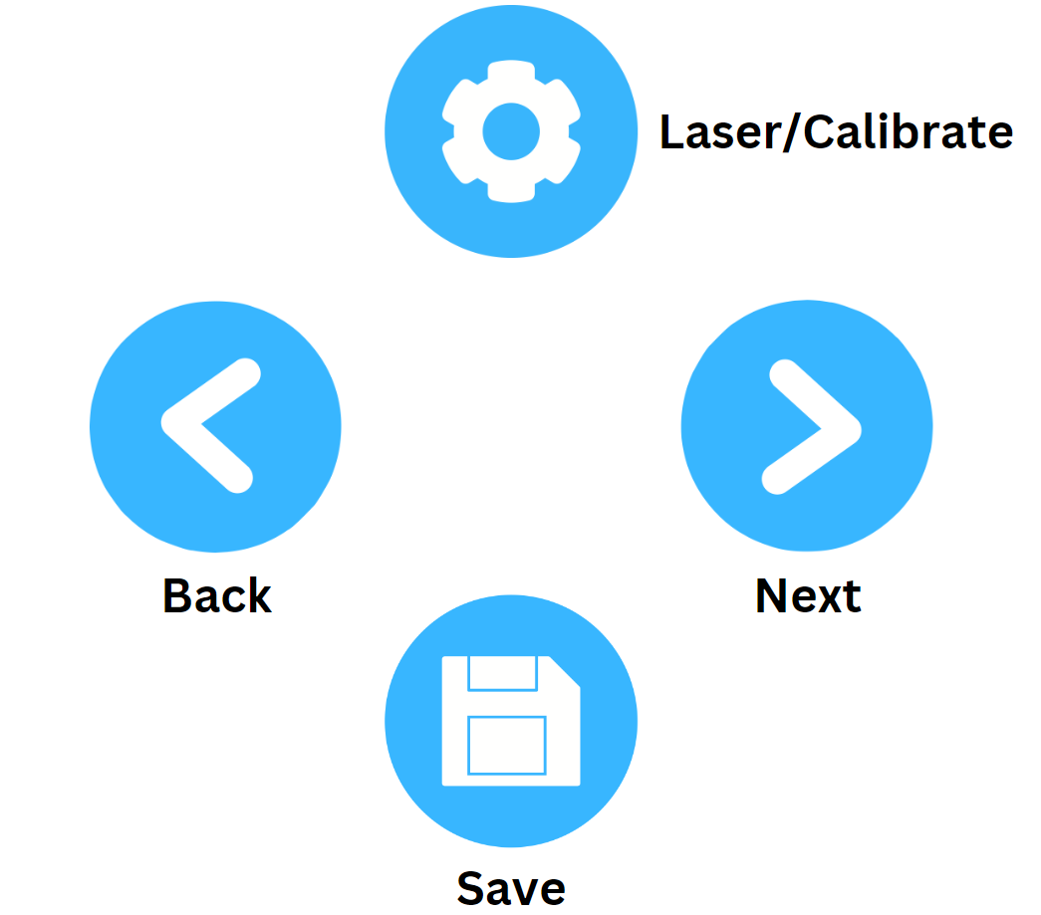

**Laser/Calibrate:**

* **(DISTANCE MODE)** For Laser press for 1 second to turn on and off
* **(ANGLE MODE)** For Calibrate press for 5 seconds to calibrate
  + When calibrating **PLACE IT IN A FLAT SURFACE** and wait for it to Finish

**Back/Next:**

* For Navigation

**Save:**

* If press for 1-3 seconds the last recorded data will be saved to the SD card
* The SD card has two excel file one for Distance and one for Angle

**Sensors used**

**Ultrasonic sensor:** for measuring distance, accuracy is (+-1cm to 2cm).

**MPU6050:** for measuring angle, not accurate need to calibrate every time there’s a better version for this the **MPU9250** heres the video reference for explanation:<https://www.youtube.com/watch?v=USa3HFLnrlk&t=298s>

**Boards**

**Arduino Nano:** The main board

**Node MCU ESP8266:** sapat na sana yung Arduino nano kaso kinukulang ng memory so ginamit ko tong nodeMCU para sa pag save ng info sa SD card Arduino nano din sana gagamitin ko kaso ang tagal dumating ng order ko kaya yung extra na nodemcu nalang yung ginamit ko since same lang naman sila ng magiging function.   
Here’s the reference kung bakit hindi pwede isama sdcard module sa Arduino Nano: <https://forum.arduino.cc/t/adding-an-sd-card-to-my-oled-project/607464>

**PRICES**

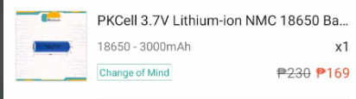

[**https://shp.ee/ql7i4y7**](https://shp.ee/ql7i4y7) **Price: 169**

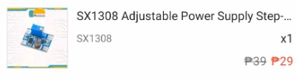

[**https://shp.ee/luz93su**](https://shp.ee/luz93su) **Price: 29**

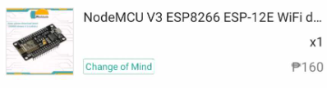

[**https://shp.ee/qqlc91o**](https://shp.ee/qqlc91o) **Price: 160**

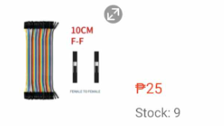

[**https://shp.ee/06y1ixq**](https://shp.ee/06y1ixq) **Price: 25**

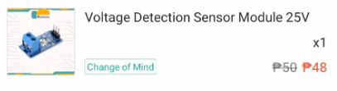

[**https://shp.ee/ubi8dcf**](https://shp.ee/ubi8dcf) **Price: 48**

**Shipping Fee: 35 + 35 = 70**

***TOTAL: 501***



